**Lab5 Submission**

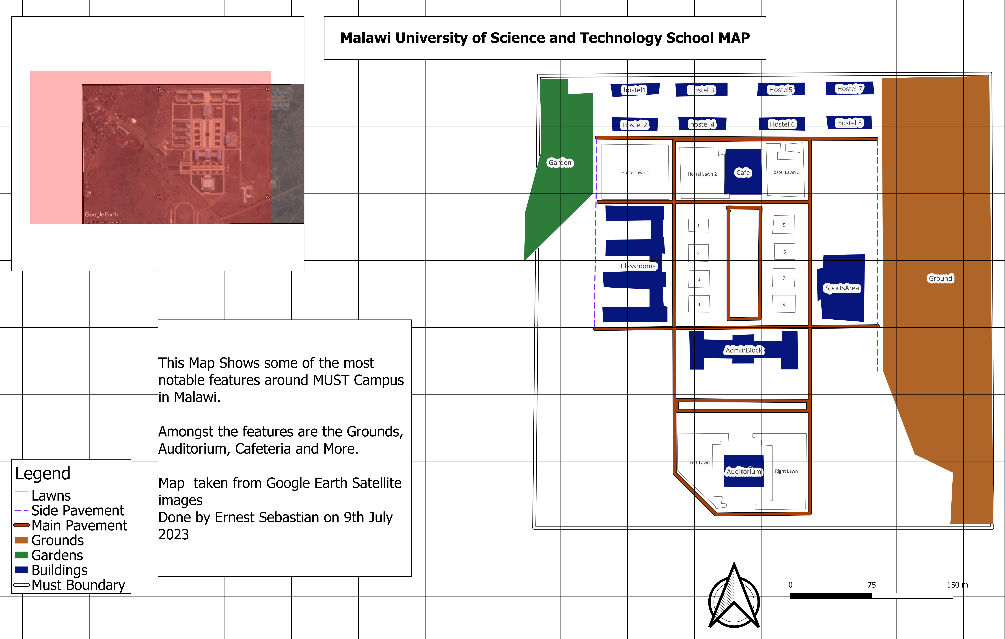

**Explanation**

In this exercise, I gained a solid understanding of the digitizing process, specifically focusing on converting a scanned map image into a digital format. The initial step involved exploring the data and familiarizing myself with the map's coordinate system. Georeferencing the map was crucial as it allowed me to establish specific reference points and concentrate on the relevant portions for the exercise. Additionally, I set the Coordinate Reference System to WGS 84, which simplified georeferencing across all map layers. By entering ground control points, I defined the boundaries of my working area, enabling a more targeted approach within the overall map. Determining and implementing the appropriate transformation settings, using the Projective method, played a vital role since it was well-suited for scanned maps, and I utilized four ground control points. Finally, onscreen digitizing and GIS Data Creation enhanced my comprehension as I began adding the necessary information, ultimately contributing to the creation of a comprehensive map.

In conclusion, each step I learned throughout the exercise significantly contributed to my understanding and the success of the project. From exploring the data and georeferencing the map to setting the coordinate system and defining the boundaries, all the way to selecting the appropriate transformation settings and engaging in onscreen digitizing, each aspect played a pivotal role. This exercise provided me with a valuable experience in the digitizing process and highlighted the importance of each step in achieving accurate and comprehensive map digitization.